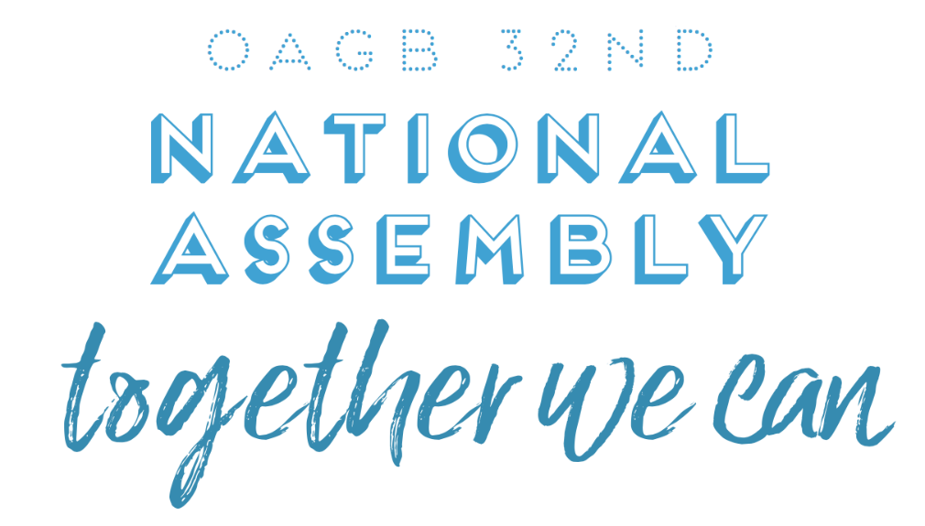

**Friday 20th October 🡪 Sunday 22nd October 2017**

|  |  |  |  |  |  |  |  |
| --- | --- | --- | --- | --- | --- | --- | --- |
| **Your Details** | | | **BOOKING FORM AND SUPPLEMENTARY**  **INFORMATION PACK** | | | | |
| **First Name** |  | |
| **Surname** |  | |
| **Telephone Number** |  | |
| **Email** |  | |
| **Will You Be Representing Your Group/Intergroup**  (And Therefore Eligible To Vote At the Assembly)? | | | **Yes** |  | | **No** |  |
| **I****f Yes, Then Which Group/Intergroup**  **Will You Be Voting On Behalf Of?** | |  | | | | | |
| **Is This Your First Time At National Assembly?** | | | **Yes** |  | **No** | |  |

|  |  |  |  |  |  |  |  |  |
| --- | --- | --- | --- | --- | --- | --- | --- | --- |
| **Service** | | | | | | | | |
| Our Convention Could Not Go Ahead Without Those Willing To Do Service | | | | | | | | |
| **Would You Like To Give General Service At This Event?**  (For example – registration desk, timekeepers, greeters, ballot counters) | | | **Yes** | |  | **No** | |  |
| **Would You Like To Speak On The Topic ‘Together We Can?’**  (Please note the current 1 year abstinence requirement to speak on the topic) | | | **Yes** | |  | **No** | |  |
| **If Yes, Please Note Your Length Of Abstinence:** |  | Years | |  | | | Months | |

|  |  |  |  |  |
| --- | --- | --- | --- | --- |
| **Register For The Assembly And Convention (Via North-West Intergroup)** | | | | |
| **Registration Fees** | | | | |
| **Item** | | **Time** | **Fee** | **Tick If You Are Booking** |
| **Assembly** | | Friday Evening/Saturday All Day | **£22.00** |  |
| **Convention** | | Sunday | **£12.00** |  |
| **Booking Instructions** | | | | |
| You book this through North-West Intergroup, and not via the hotel. | | | | |
| **Step** | **Details** | | | |
| **1** | Electronic bank transfer to Account: Name: OA Northwest Intergroup, Sort Code: 77-19-13, Account No.: 30765868. Use ‘NA17’ and your full name as the reference. | | | |
| **OR** | | | | |
| **1** | Cheques should be made payable to OA Northwest Intergroup and posted to the booking secretary (Postal address can be requested from [nationalassembly2017@gmail.com](mailto:nationalassembly2017@gmail.com)). | | | |
| **2** | Complete the **‘Your Details’** and **‘Service’** on this form and return to [**nationalassembly2017@gmail.com**](mailto:nationalassembly2017@gmail.com) | | | |
| **Registration Fees to be paid in advance to North-West Intergroup by 17th September 2017** | | | | |

|  |  |  |  |  |
| --- | --- | --- | --- | --- |
| **Your Dinner Choices And Tea/Coffee** | | | | |
| * **All meals have no sugar/white flour added and sauces are served separately.** * Breakfast and lunch on Saturday and Sunday are served buffet-style. * You will need to choose your main meal on both Friday and Saturday on the next page. * There will be access to a fruit cart at break times and meal times. | | | | |
| **Friday Evening Meal** | | | | |
| **Meal** | **Options** | | **Please Choose One** | |
| **Starter** | Choice Of Brown Or White Roll With Butter Or Margarine, And: | |  | |
| Vegetable Soup | |  | |
| Mozzarella And Tomato Salad | |  | |
| Prawn Cocktail With Marie Rose Sauce | |  | |
| **Main Meal** | Chicken Breast, Gravy, New Potatoes, Seasonal Vegetables | |  | |
| Vegetable Lasagne With Wholemeal Pasta, Green Salad | |  | |
| Salmon, Watercress Sauce, New Potatoes, Seasonal Vegetables | |  | |
| **Saturday Evening Meal** | | | | |
| **Meal** | **Options** | | **Please Choose One** | |
| **Starter** | Choice Of Brown Or White Roll With Butter Or Margarine, And: | |  | |
| Carrot And Coriander Soup | |  | |
| Melon And Berries | |  | |
| Chicken Salad With Caesar Dressing | |  | |
| **Main Meal** | Vegetable Curry With Brown Rice | |  | |
| Cod, Tomato Salsa, Roasted Potato Wedges, Seasonal Vegetables | |  | |
| Beef Slices, Gravy, Roasted Potato Wedges, Seasonal Vegetables | |  | |
| **Allergies/Specific Requirements** | | | | |
| For any specific requirements/allergy enquiries email Suzi on [suzibrown61.sb@gmail.com](mailto:suzibrown61.sb@gmail.com).  Near to the hotel are local shops and restaurants for self-catering. | | | | |
| **Lunch/Tea/Coffee** | | | | |
| Are you booking lunch for Saturday (£14)? | | **YES** | | **NO** |
| Are you booking lunch for Sunday (£14)? | | **YES** | | **NO** |
| Are you booking tea/coffee for Saturday (£5)? | | **YES** | | **NO** |
| Are you booking tea/coffee for Sunday (£5)? | | **YES** | | **NO** |

|  |  |  |  |  |  |
| --- | --- | --- | --- | --- | --- |
| **Booking Accommodation And Catering** | | | | | |
| **You Book Directly With The Hotel, And Not Through North-West Intergroup/OAGB** | | | | | |
| **Rates** | | | | | |
| **Single Occupancy** | | Per Room, Per Night, Dinner, Bed & Breakfast | | **£108** | |
| **Based On 2 People Sharing** | | Per Room, Per Night, Dinner, Bed & Breakfast | | **£130** | |
| Check in from 3:00pm; checkout at 11:00am. (Leisure facilities available to use before check in) | | | | | |
| **Other Hotel Catering** | | | | | |
| If you are a day delegate are you booking dinner for Saturday evening? (£20) | | | **YES** | | **NO** |
| **Booking Instructions** | | | | | |
| **Step** | **Details** | | | | |
| **1** | Telephone booking only - phone the hotel reservation department on **01477 536 666** (24hours). | | | | |
| **2** | **Please quote ‘OA’** when speaking to the representative. | | | | |
| **3** | You will be asked to pay over the phone by credit card for a non-refundable **£20 deposit**, taken within 14 days of booking. | | | | |
| **4** | The remaining balance (accommodation and catering) is **payable to the hotel on departure.** | | | | |
| **5** | Complete this form and return to [**nationalassembly2017@gmail.com**](mailto:nationalassembly2017@gmail.com) | | | | |
| **To Guarantee Availability And These Special Rates, Book With The Hotel By 1st September 2017** | | | | | |

|  |  |
| --- | --- |
| **Total Costs [The Following Is The Maximum Cost If Booking Full-Board For The Weekend]** | |
| Cost Of Hotel Accommodation Friday And Saturday Nights, All Meals, Including Lunch Both Days, Tea/Coffee Both Days And Registration Both Days **[Sharing, Per Person]:** | Cost Of Hotel Accommodation Friday And Saturday, All Meals, Including Lunch, Tea/Coffee Both Days And Registration Both Days  **[Individual Room, Per Person]:** |
| **£202** | **£288** |

|  |  |  |  |  |
| --- | --- | --- | --- | --- |
| **Once this form is complete, please return to** [**nationalassembly2017@gmail.com**](mailto:nationalassembly2017@gmail.com) **and call the number below if you have any queries.** | | | | |
| **General Enquiries** | Call | Cheryl - 07568407866 | Email | nationalassembly2017@gmail.com |

**SUPPLEMENTARY INFORMATION**

|  |  |  |  |  |  |
| --- | --- | --- | --- | --- | --- |
| **Draft Programme Of Events** | | | | | |
| **Friday** | | | **Sunday (Convention)** | | |
| **From** | **To** | **Activity** | **07:00** | **08:00 Bird Meeting** | **Early Bird Meeting** |
| **15:00** | **18:00** | Registration | **07:00** | **09:00** | Breakfast |
| **18:30** | **19:30** | Dinner | **08:30** | **10:00** | Registration |
| **20:00** | **22:00** | Evening Workshop* | **10:00** | **12:30** | ‘Together We Can’ Convention** |
| **22:00** | **23:00** | Night Owl Meeting | **12:30** | **13:30** | Lunch |
| **Saturday (Assembly)** | | | **14:00** | **16:30** | ‘Together We Can’ Convention |
| **From** | **To** | **Activity** | **16:30** | **-** | End |
| **07:00** | **08:00** | Early Bird Meeting | *OAGB workshop - this is in relation to the business for the Saturday. It is important that delegates representing their group at the Assembly attend this.  **The OAGB National Service Board AGM will run concurrently (09:30 – 13:00) with the convention (observers welcome). | | |
| **07:00** | **09:00** | Breakfast |
| **08:30** | **09:00** | Registration |
| **09:00** | **10:00 Workshop** | Morning Workshop* |
| **10:00** | **13:00** | Assembly |
| **13:00** | **14:00** | Lunch |
| **14:00** | **17:00** | Assembly |
| **19:00** | **20:00** | Dinner |
| **20:30** | **22:00 Activity/Entertainment** | Evening Activity/Entertainment |
| **22:00** | **23:00 Owl Meeting** | Night Owl Meeting |

|  |  |
| --- | --- |
| **Location And Travel Information** | |
| **Location** | |
| Cranage Hall, Byley Lane, Holmes Chapel, CW4 8EW | |
| **By Train** | The nearest mainline railway stations are Crewe and Macclesfield, which are approximately 20 minutes by taxi from the hotel. The nearest local station is Holmes Chapel, just five minutes away and convenient when travelling to/from Manchester city centre. **It is recommended to book taxis in advance.** |
| **By Car** | Cranage Hall is easily accessible from the M6 via the A50. Parking is extensive and free for guests of the hotel, conference venue, and leisure club. |
| **By Air** | Manchester Airport is just 18 miles—or approximately 25 to 30 minutes via car or taxi—from Cranage Hall. Ample parking is available on the hotel grounds |

|  |  |
| --- | --- |
| **General Information** | |
| **Delegate Assistance** | If your group has a willing delegate but needs financial assistance, please contact the OAGB Treasurer at [treasurer@oagb.org.uk](mailto:treasurer@oagb.org.uk) for guidance on how to apply or download an application from the OAGB website at [www.oagb.org.uk](http://www.oagb.org.uk). Deadline for receipt of delegate assistance forms: 31st July 2017. |
| **Assembly Packs** | Delegate packs will be available from 31st August 2017. Please ensure your group has given contact details (preferably email) to your Intergroup Chair/Secretary to allow them to email the packs to you. Packs will also be available for download on the OAGB website at [www.oagb.org.uk](http://www.oagb.org.uk). Each delegate should read and bring their own copy of the pack to the Assembly. |
| **Literature** | OA literature will be sold throughout the weekend. |