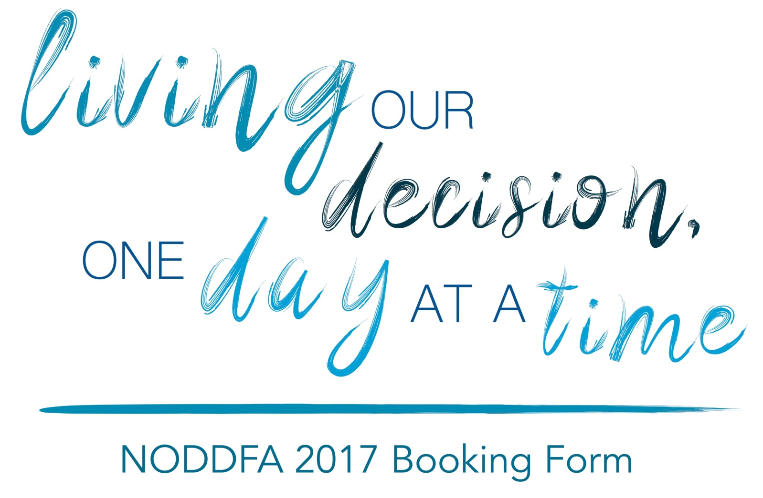

Please fill in the form below, and send it to
nwig.retreat@gmail.com AND info@noddfa.org.uk.

Name
Address
Telephone
Email
Dietary Requirements
Any Other Requirements?

